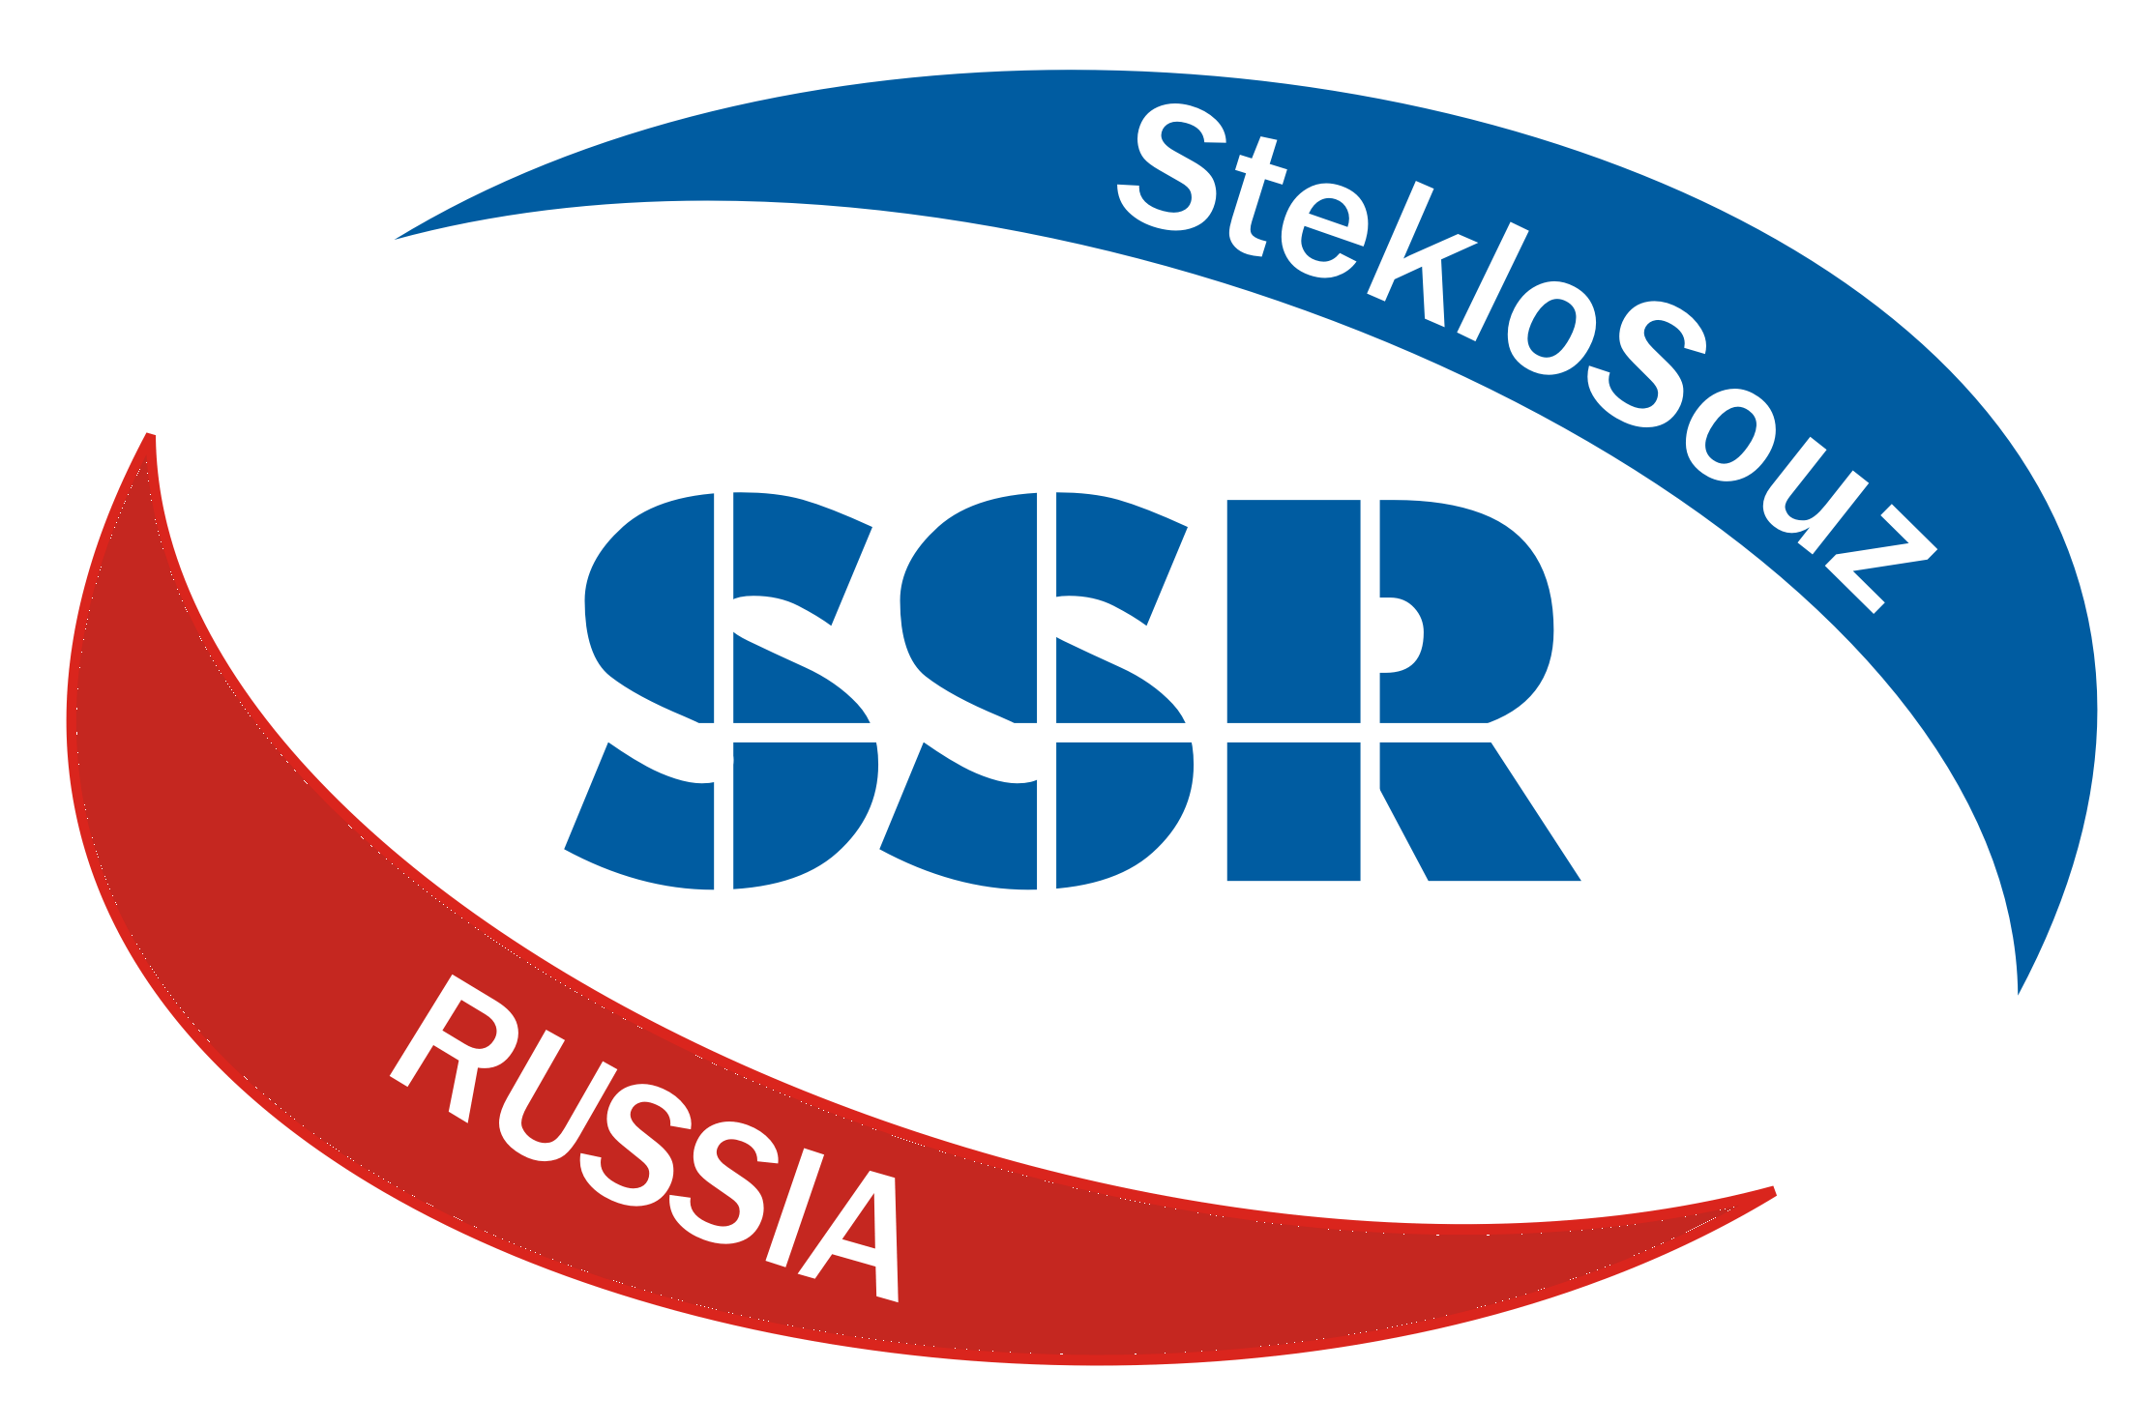 | Application for participation in  International Competition
«The leader of the glass industry – 2024»
Please fill out this application and send to
e-mail: konkurs@steklosouz.ru admin@steklosouz.ru
Contact person: Kovaleva Maria

Name of company:
The contact person
Contact phone and email:
Nomination: 1.
2.
3.

Requisites:
Legal address with postal code
Address actual with an index
Phone fax
payee's bank
Correspondent account
BIC Bank Identifier Code
Account
Taxpayer Identification Number (INN) / Tax Registration Reason Code (KPP)
Full name of the head
Acting on the basis

We hereby confirm our participation in the competition. Please send the contract and invoice, we guarantee full payment.

The application can not be canceled by the participant unilaterally.

Signature and stamp

_________________________ FULL NAME________________________ date ____________

